B. P. Chaliha College, Nagarbera
ASSESSMENT YEAR 2020-21
Date of Issue: 11st June 2021
Last date: 21th June 2021
[Total number of Respondents 152]

- How much of the syllabus was covered in the class?
4 – 85 to 100% 44 students
3 – 70 to 84% 60 students
2 – 55 to 69% 24 students
1– 30 to 54% 16 students
0 –Below 30% 08 students

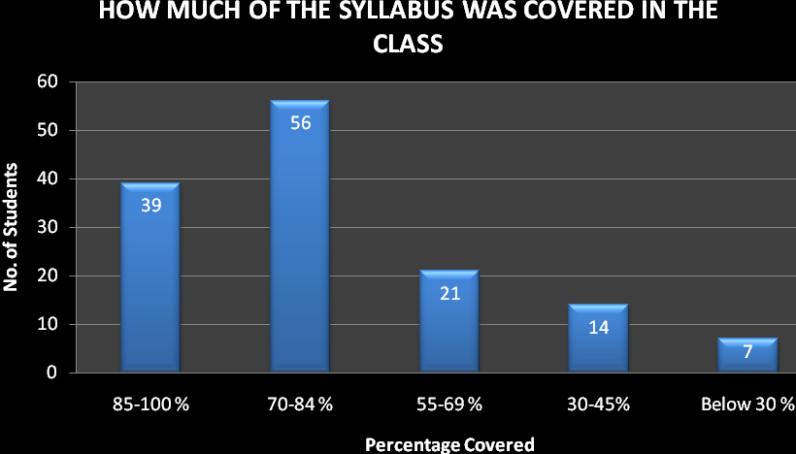

- How well did the teachers prepare for the classes?
4 –Thoroughly 42 students
3 – Satisfactorily 59 students
2 – Poorly 30 students
1 – Indifferently 14 students
0 – Won’t teach at all 7students

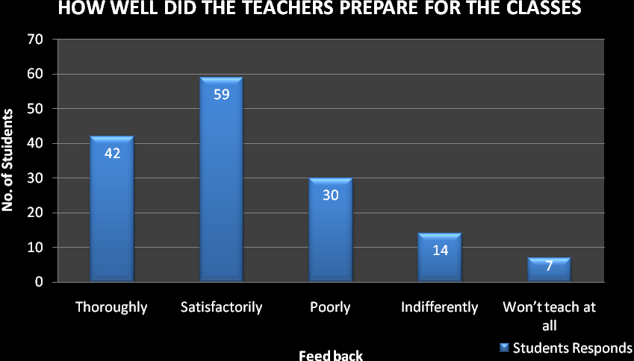

- How well were the teachers able to communicate?
4 – Always effective 51 students
3 – Sometimes effective 32 students
2 – Just satisfactorily 43 students
1– Generally ineffective 18 students
0– Very poor communication 8 students

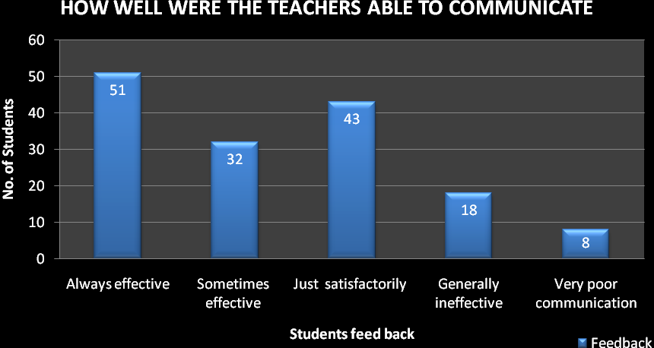

- The teacher’s approach to teaching can best be described as
4– Excellent 49 students
3 – Very good 44 students
2 – Good 29 students
1 – Fair 17 students
0– Poor 13 students

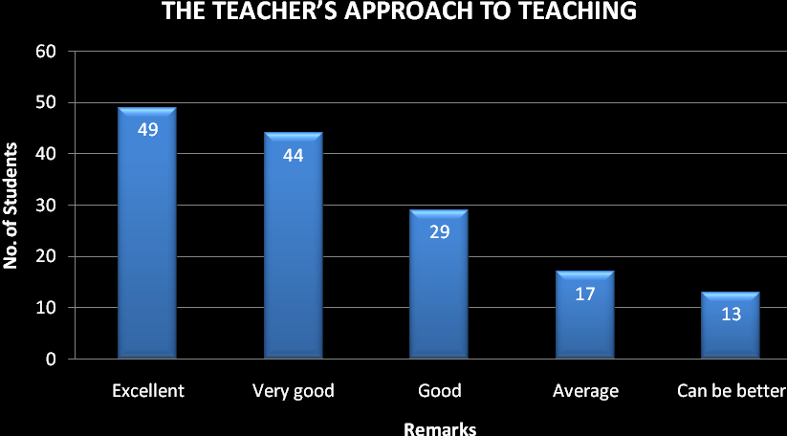

- Fairness of the internal evaluation process by the teachers.
4 – Always fair 59 students
3 – Usually fair 41 students
2 – Sometimes unfair, 29 students
1 – Usually unfair, 12 students
0– Unfair, 11 students

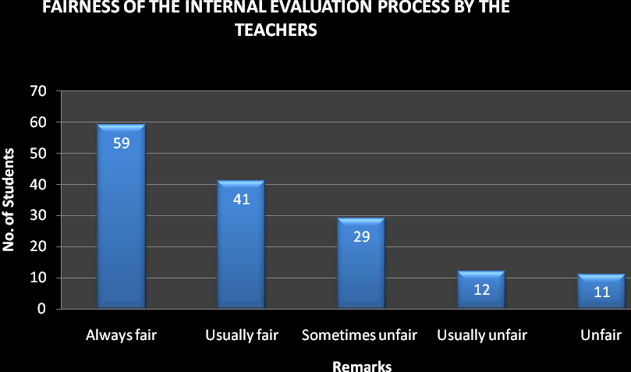

- Was your performance in assignments discussed with you?
4 – Every time 71 students
3 – Usually, 25 students
2 – Occasionally/Sometimes 36 students
1 – Rarely 12 students
0– Never 8 students
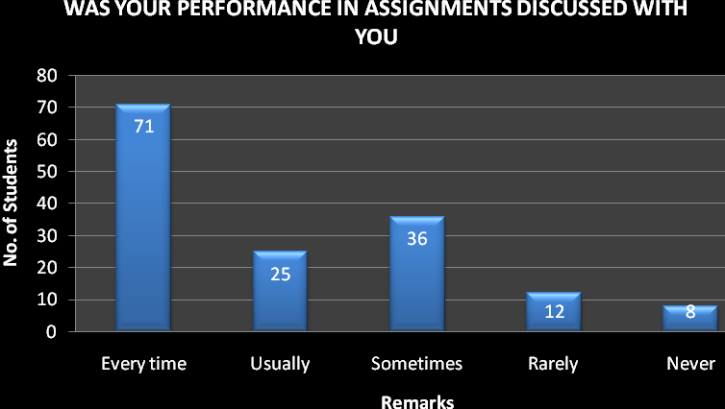

- The institute takes active interest in promoting internship, student exchange, field visit opportunities for students.
4 – Regularly 63 students
3 – Often 35students
2 – Sometimes 30students
1 – Rarely 16 students
0– Never 8 students

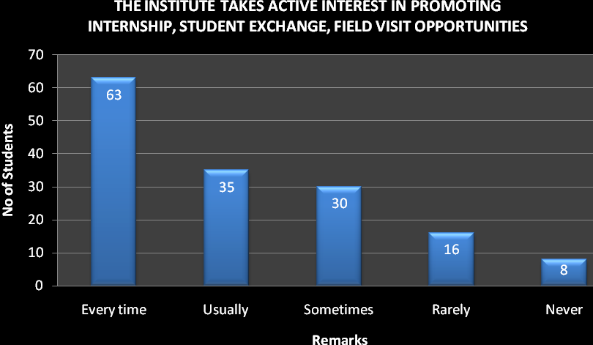

- The teaching and mentoring process in your institution facilitates you in cognitive, social and emotional growth.
4 – Significantly 52 students
3 – Very well 49 students
2 – Moderately 26 students
1 – Marginally 15 students
0– Not at all 10 students

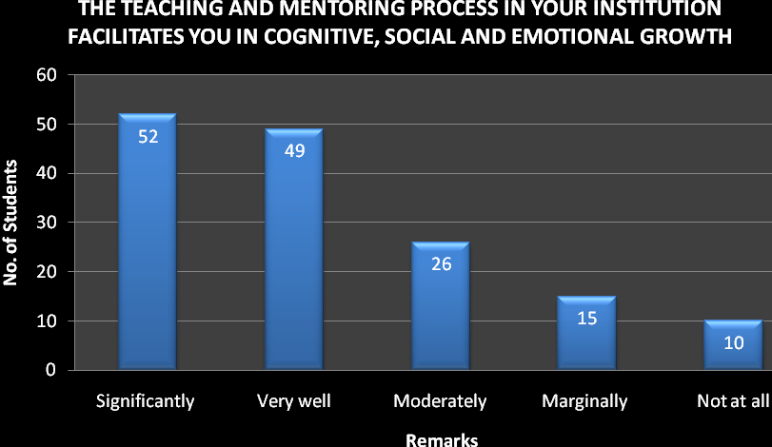

- The institution provides multiple opportunities to learn and grow.
4 – Strongly agree 63 students
3 – Agree, 37 students
2 – Neutral, 24 students
1 – Disagree, 21 students
0– Strongly disagree, 7 students

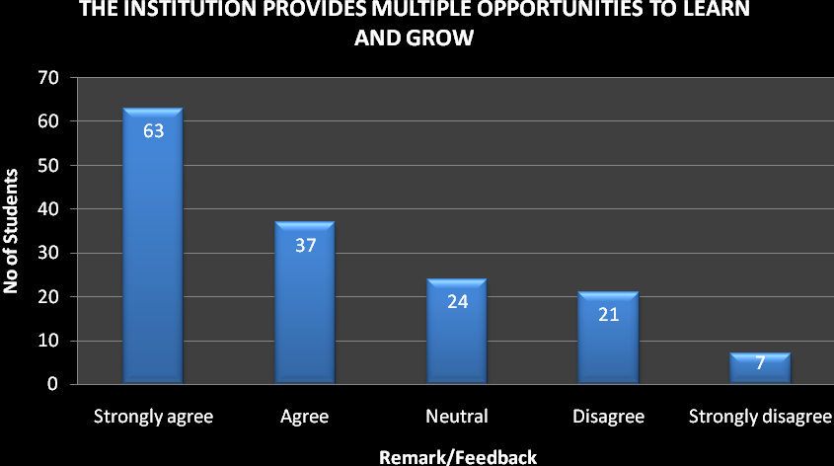
- Teachers inform you about your expected competencies, course outcomes and programme outcomes.
4 – Every time 58 students
3 – Usually, 55 students
2– Occasionally/Sometimes, 21students
1 – Rarely, 14 students
0– Never, 04 students

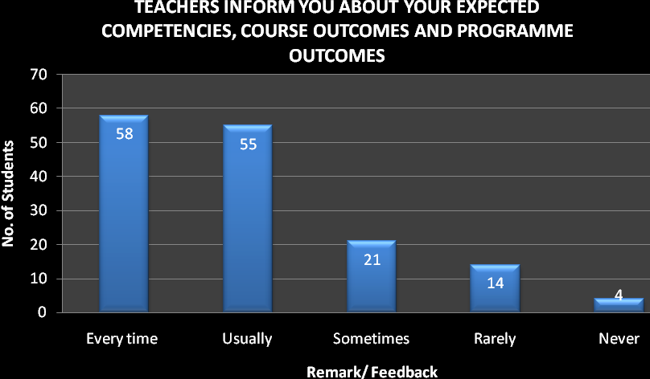

- Your mentor does a necessary follow-up with an assigned task to you.
4 – Every time, 69
3 – Usually, 35
2 – Occasionally/Sometimes, 21
1 – Rarely, 12
0 – I don’t have a mentor, 15

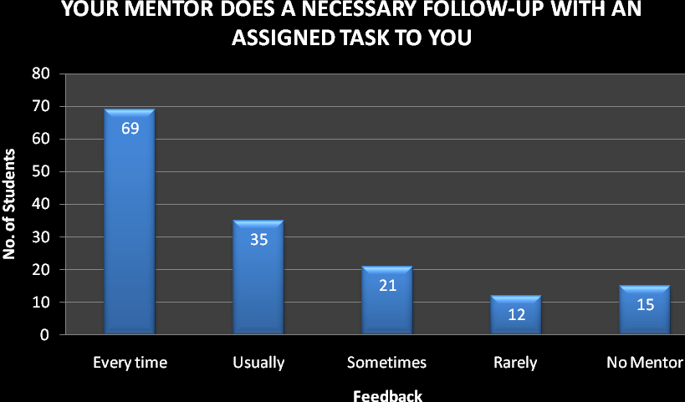

- The teachers illustrate the concepts through examples and applications.
4 – Every time, 58
3 – Usually, 41
2 – Occasionally/Sometimes, 33
1– Rarely, 14
0 – Never, 06

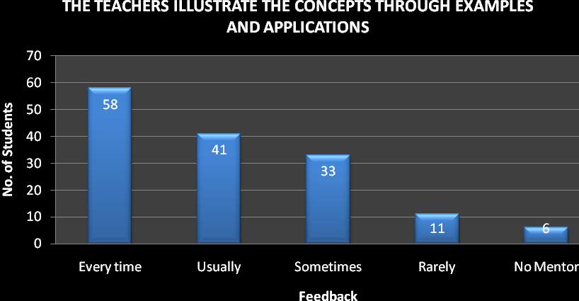

- The teachers identify your strengths and encourage you with providing right level of challenges.
4 – Fully 69
3 – Reasonably 41
2 – Partially 33
1 – Slightly 08
0– Unable to 01

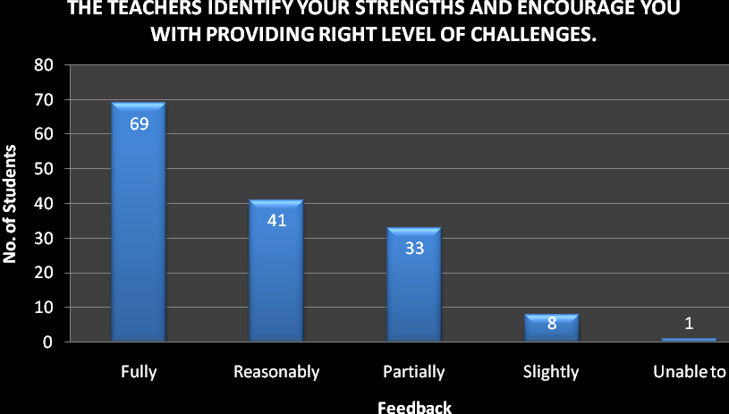

- Teachers are able to identify your weaknesses and help you to overcome them.
4 – Every time, 44
3 – Usually, 48
2 – Occasionally/Sometimes, 41
1 – Rarely, 08
0 – Never, 11

,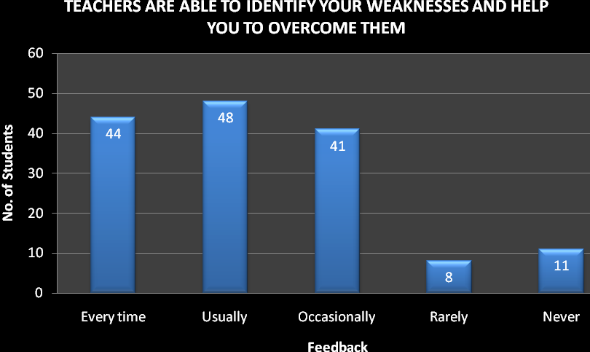
- The institution makes effort to engage students in the monitoring, review and continuous quality improvement of the teaching learning process.
4 – Strongly agree, 60students
3 – Agree, 47 students
2 – Neutral, 33 students
1 – Disagree, 09students
0 – Strongly disagree, 03 students

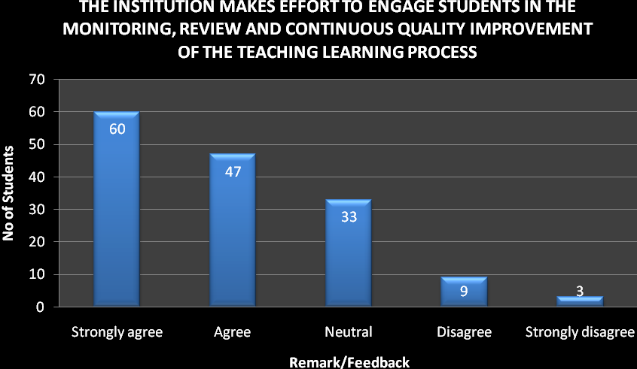

- The institute/ teachers use student centric methods, such as experiential learning, participative learning and problem solving methodologies for enhancing learning experiences.
4 – To a great extent 62 students
3 – Moderate, 44 students
2 – Somewhat 33 students
1 – Very little, 12 students
0 – Not at all 01 students

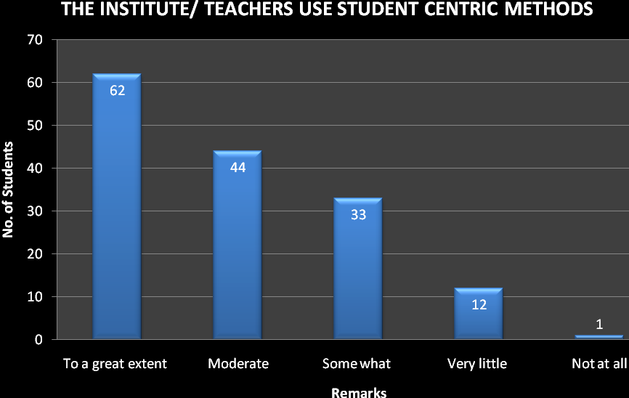

- Teachers encourage you to participate in extracurricular activities.
4 – Strongly agree 64 students
3 – Agree 43 students
2 – Neutral 28 students
1 – Disagree 08 students
0 – Strongly disagree 09 students

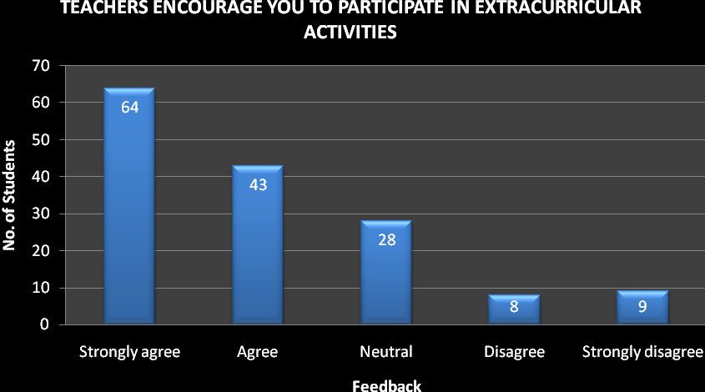

- Efforts are made by the institute/ teachers to inculcate soft skills, life skills and employability skills to make you ready for the world of work.
4 – To a great extent 59 students
3 – Moderate 35 students
2 – Somewhat 29 students
1 – Very little 17 students
0 – Not at all 12 students

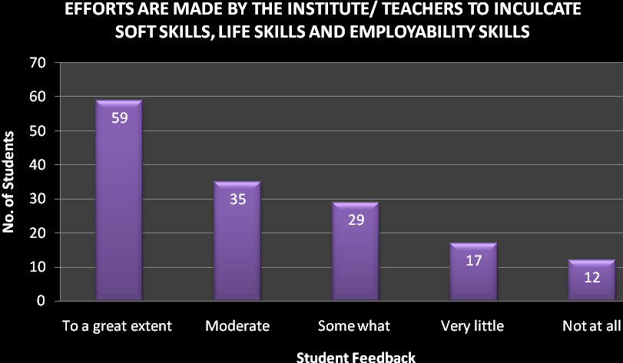

- What percentage of teachers use ICT tools such as LCD projector, Multimedia, etc. while teaching.
4 – Above 90% 53 students
3 – 70 – 89% 31 students
2 – 50 – 69% 27 students
1 – 30 – 49% 21 students
0 – Below 29% 20 students

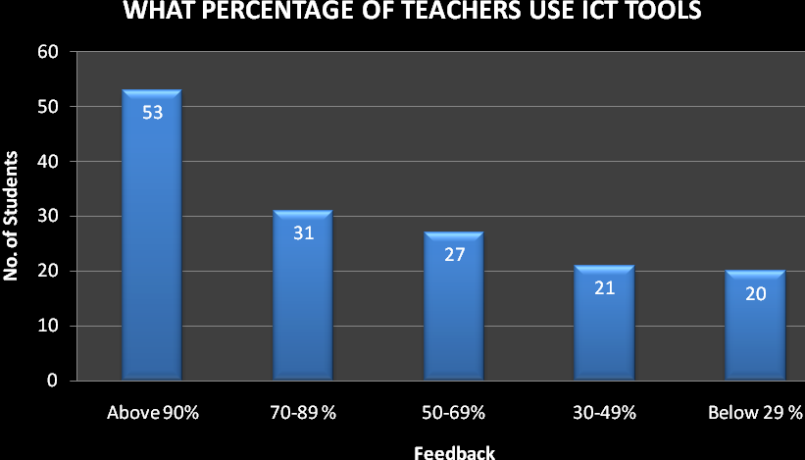
- The overall quality of teaching-learning process in your institute is very good.
4 –Strongly agree 63 students
3 – Agree 39 students
2 – Neutral 21 students
1 – Disagree 17students
0 – Strongly disagree 12 students

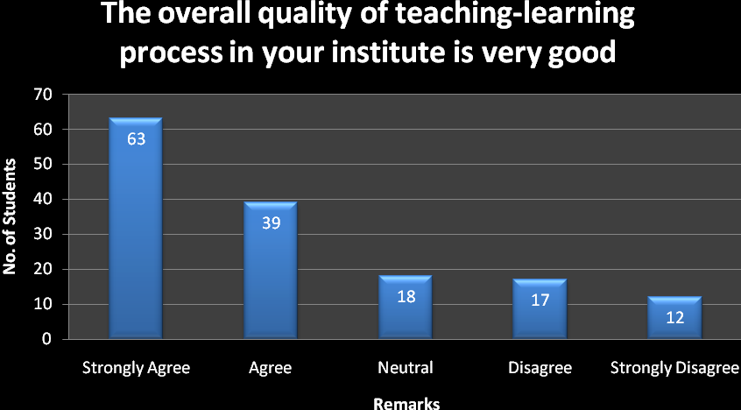

- Give three observation / suggestions to improve the overall teaching – learning experience in your institution.

- Around 40 percentages of students suggested for an indoor stadium in the college.
- More than 60 percent students requested for better sanitary toilet facility in the college campus.
- Few students requested for a photocopier facility in the college campus.

